Azure git working with merge conflicts

Open two cmd and execute the below ones

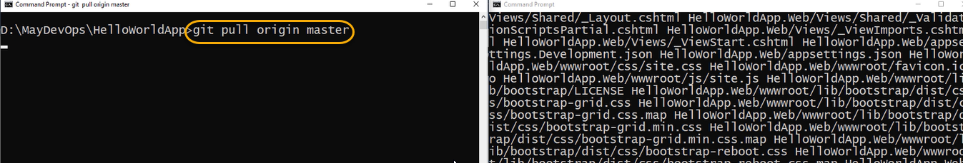

And now if you are running on the git pull origin master on second cmd

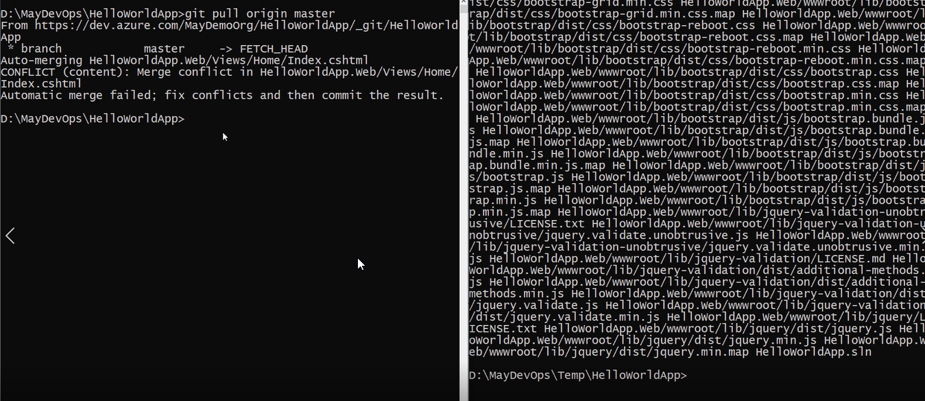

If you see any error then edit the code .

And then click on git add .

git commit -m “okay done changes”

and then execute git push origin master and git pull origin master

and execute the below one

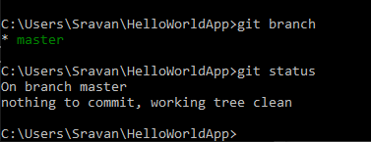

It should show the same in both CMDS

And for one cmd execute the below ones

git config user.name user1

git config user.email [user1@dss.com](mailto:user1@dss.com)

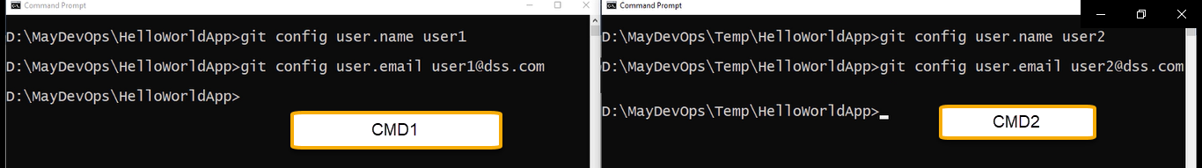

And these are saved in local git repo

Code .

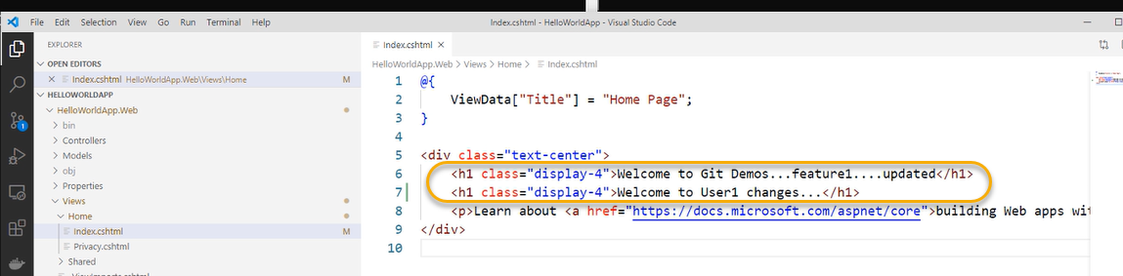

git add . and git commit -m “new user1 tittle added”

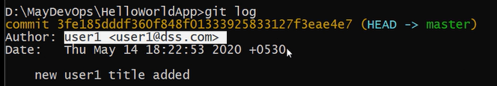

git push origin master

if you get any error then configure the below one

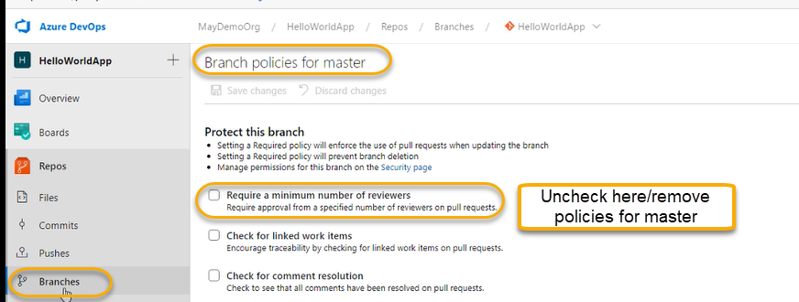

Direct commit to master is NOT possible if you attach any Branch Policy

And gain run git push origin master

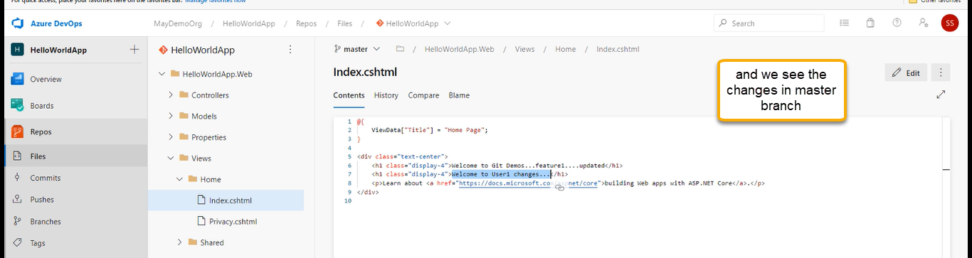

User2/CMD2

Code .

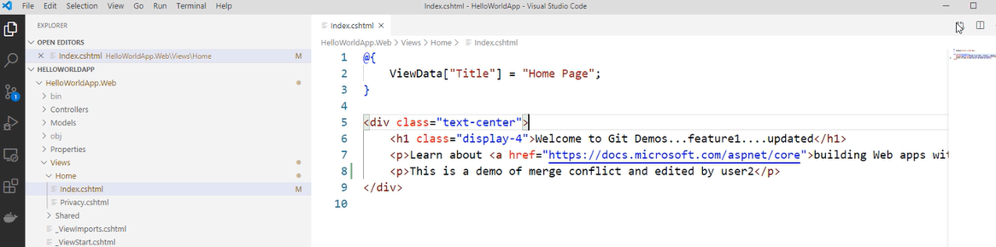

Where user2 does NOT know the changes made by user 1( git add . and git commit -m “some text added by user2”

When he tries to push his changes we will get an error

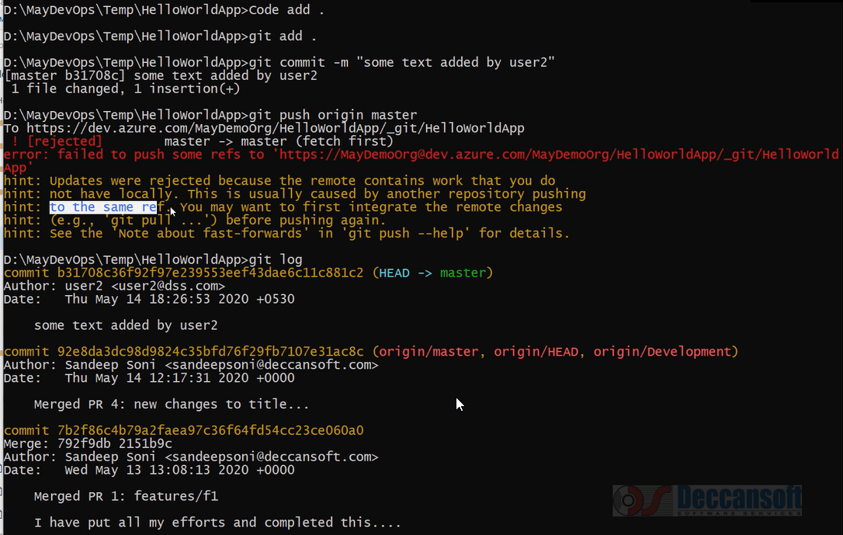

Execute the git pull origin master

git push origin master

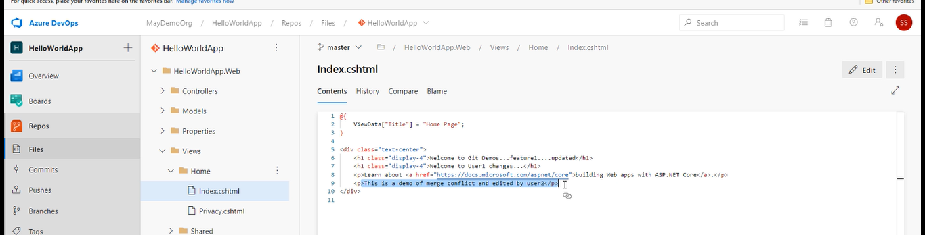

If two developers are working on the same line

Execute the CMD1 and CMD2 below ones

git pull origin master

now edit the code . (CMD1)

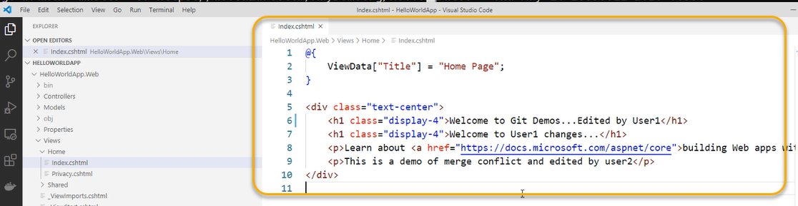

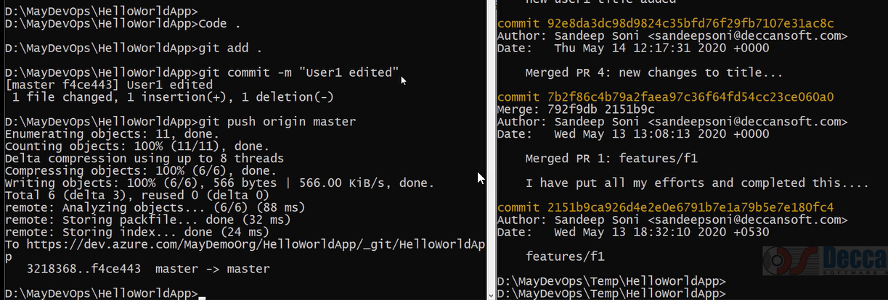

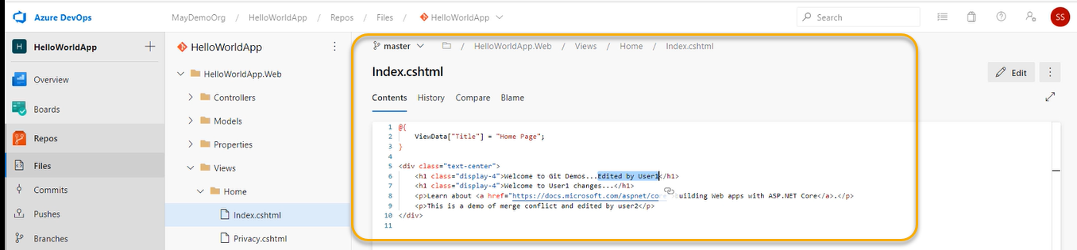

ON CMD 2 execute the Code .

Do the changes on same line

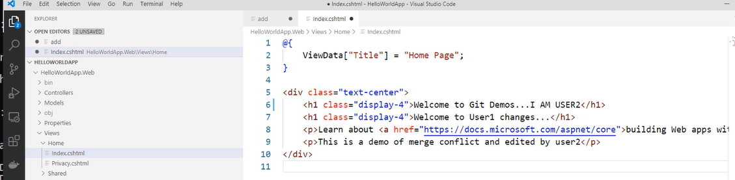

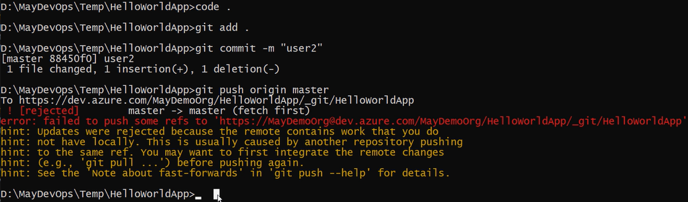

So, execute git pull origin master and again we see the error below

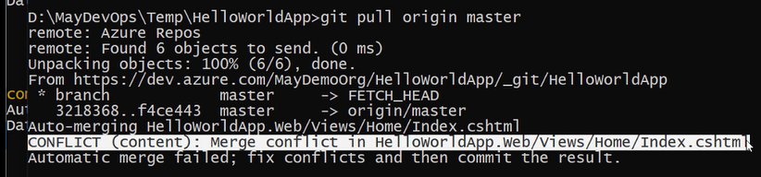

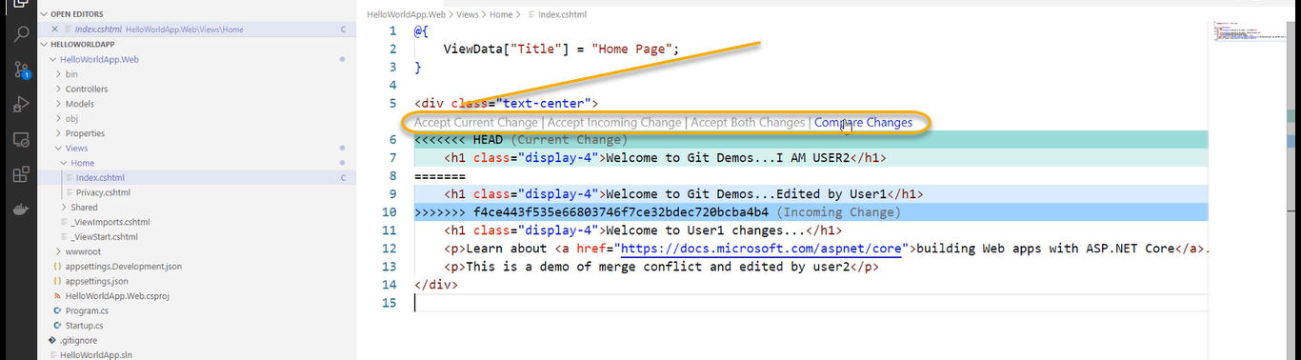

And delete the manual steps

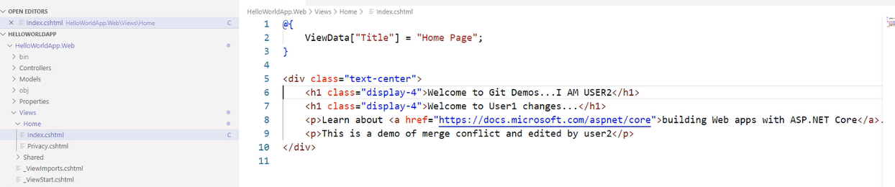

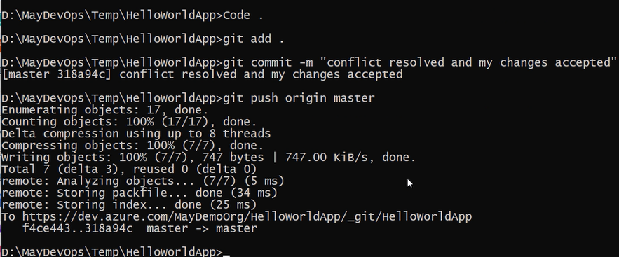

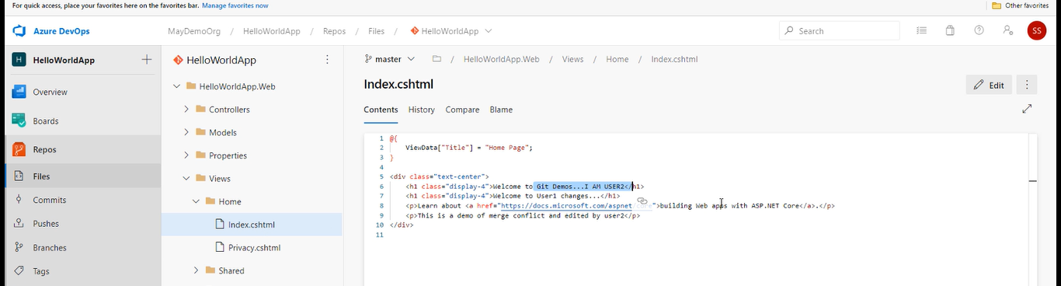

If you are doing the manual edits to code then we are doing the changes to the same line and if you do changes to different line then it will do automatically